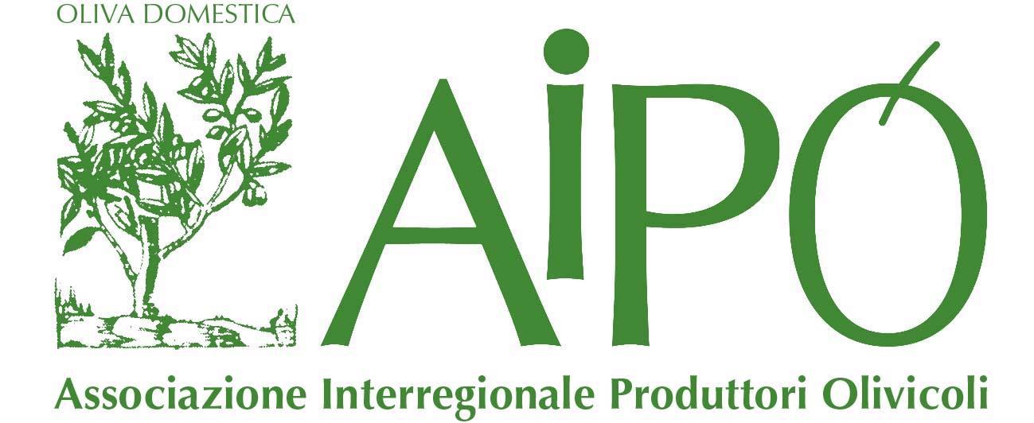 | CONCORSO OLEARIO INTERNAZIONALE  AIPO D’ARGENTO 2015
Registration will be open from January to March 2015
“Aipo d’Argento 2015”:
it’s already scheduled
the 12th edition of the International Extra Virgin Olive Oil Competition

In 2015 the International Extra Virgin Olive Oil Competition “Aipo d’Argento” – that in 2014 saw the participation of 220 oils – will celebrate 12 years since its first edition.
The Management Committee and the Organizer decided to bring forward the starting of the selection – registration will be open from January to March 2015 – in order to come to the award ceremony on the eve of EXPO 2015.
The competitors of “Aipo d’Argento 2015” will have the opportunity to exploit commercially the products with which they have taken part in the competition in the semester of the Universal Exposition, that will take place in Italy from May to October 2015 and that will lead in our country consumers and buyers from each part of the world.
This is a unique chance of promotion for all the companies, both Italian and foreign, who in these years have enrolled their best production in this Olive Oil Competition, widely recognized in the sector for its quality and its strict rules.
Italian and Mediterranean Extra Virgin Olive Oils (in 2014 the percentage of international entries was 20%) in the following categories are entitled to enter the contest

COMPETITION CATEGORIES
- Extra Virgin Olive Oil DOP/IGP (Denominazione di Origine Protetta/Indicazione Geografica Protetta)
- Extra Virgin Olive Oil ORGANIC (Organic Agriculture)
- Extra Virgin Olive Oil MONOCULTIVAR
- Extra Virgin Olive Oil 100% ITALIAN
- Extra Virgin Olive Oil MEDITERRANEAN BASIN

with three intensity fruitiness:
- light fruitiness
- medium fruitiness
- intense fruitiness

The olive oils will be evaluated by a selected panel that will include international tasters.
Registration will be open in January 2015 and the selection will end by March 2015.
For any further information, please contact AIPO (Associazione Interregionale Produttori Olivicoli), the Competition’s organizer, by fax (+39 045 8034468) or by email (info@aipoverona.it). You’ll find all the news, the details and the Official Regulation of the event “Aipo d’Argento 2015” on AIPO’s website (www.aipoverona.it).

Segreteria Concorso Oleario Internazionale Aipo d’Argento 2015
Viale Del lavoro, 52 – 37135 Verona Tel. +39 045 86 78 260 Fax +39 045 80 34 468
info@aipoverona.it www.aipoverona.it

